The American University in Cairo
School of Sciences and Engineering
ENGR 3202: Engineering Analysis and Computation I
A 1-D Transient Thermal Simulator for an Electric Vehicle (EV) Battery
Application of Newton interpolating polynomials, linear systems solvers, and initial value problems in ordinary differential equations
Team members:
Mohamed Taha (900241159)
Ahmed Khalil (900241385)
Habiba (900242966)
Malak (900241987)

Summer 2026
Submitted: July 16, 2026
Instructor: ENGR 3202 Teaching Team

b. List of Contributors
The photo below is the group selfie taken while we were working together on the project.
]
Group selfie taken during a working session.
All of us worked on the code and the report together, but every member had a main responsibility. The contributions were divided as follows:
Name | ID | Contribution
Ahmed Khalil | 900241385 | Heun and report
Habiba | 900242966 | Heun and overall validation (heun plot)
Malak | [900241987] | Euler, Thomas, part of Gauss, their plots, and debugging the code
Mohamed Taha | 900241159 | Interpolation ,gauss ,matrix creation and code cleanup

c. Abstract
In this project we developed a 1-D thermal simulator in Python for a row of 15 lithium-ion battery cells sitting on a liquid-cooled aluminium plate. The goal is to check if the battery temperature stays below the 60 °C limit during 15 minutes of fast charging. The simulator has three milestones. In the first milestone, a 2nd order Newton interpolating polynomial estimates the thermal conductivity of the water-glycol coolant at any temperature from the data in cond.txt. In the second milestone, the steady state temperatures of the 15 cells are found by building a linear system from the thermal circuit model and solving it with Gauss elimination with scaled partial pivoting. As a bonus, the user can also choose the Thomas algorithm since the matrix is tridiagonal. In the third milestone, the temperature of the hottest cell during fast charging is found by solving an ordinary differential equation with the Euler method, and also with the Heun method as a bonus.
Every numerical function was validated separately with an example from the lectures before using it in the project, and all of them gave the correct output. For the test case (Q = 5 W, fluid and ambient temperatures at 25 °C, R left = 1 K/W, and R right = 5 K/W), the coolant conductivity at 25 °C was 0.40184 W/m.K, and the hottest cell was cell number 6 with a steady state temperature of 45.220 °C. However, during fast charging the hottest cell reached about 118.6 °C, which is much higher than the 60 °C limit. This means the charging current or the cooling design must be improved for this scenario.
d. Background Review of the Problem
Electric vehicles store their energy in packs of lithium-ion cells. When the car is driving or charging, a current passes in every cell and the internal resistance of the cell generates heat by Joule heating. This heating is the strongest during fast charging because the charging current is very high. If the cells become too hot, the battery degrades faster and it can even become a safety problem. Because of that, battery packs are cooled by a liquid coolant, and engineers need to predict the cell temperatures before building the pack [4].
In this project we study a simplified 1-D model of this problem. A row of 15 lithium-ion cells sits on an aluminium plate, and between them there is a thermal interface material (TIM) paste. Under the plate there is a channel with a water-glycol coolant. The heat generated inside every cell moves in two ways: horizontally by conduction from cell to cell, and vertically through the TIM and the aluminium plate to the coolant. Every one of these paths is represented by a thermal resistance, so the whole pack becomes a thermal circuit, exactly like an electric circuit where temperature is the voltage and heat flow is the current [3].
The thermal conductivity of the water-glycol coolant is not constant, it changes with temperature. Its values at discrete temperatures are given in a data file based on the measurements of Bohne et al. [2], so interpolation is needed to get the conductivity at the fluid temperature the user wants.
Two scenarios are analysed. In the first one, the car is driving on the highway towards the charging station, and every cell generates a constant load Q. This is a steady state problem and it gives a linear system of 15 equations. In the second one, the car is fast charging for 15 minutes. The charging current starts at 120 A and then decays exponentially, and the cell resistance changes with temperature, so the heat generation changes with time. This is a transient problem, and it is solved for the hottest cell only while its two neighbours are locked at their steady state temperatures. The goal is to make sure the battery temperature will not exceed 60 °C.
e. Background on the Numerical Methods Employed
All the methods below are taken from the lectures and from Chapra and Canale [1]. They were coded from scratch in Python without using any built-in numerical functions.
e.1 2nd Order Newton Interpolating Polynomial
Interpolation estimates the value of a function between known data points. For three points, the 2nd order Newton polynomial is [1]:
$$f_{2}(x) = b_{0} + b_{1}(x - x_{0}) + b_{2}(x - x_{0})(x - x_{1})$$
where the coefficients are the finite divided differences:
$$b_{0} = f(x_{0}) , b_{1} = \frac{f(x_{1}) - f(x_{0})}{x_{1} - x_{0}}$$
$$b_{2} = \frac{f[x_{2},x_{1}] - f[x_{1},x_{0}]}{x_{2} - x_{0}}$$
Our function first selects the three data points that are the nearest to the requested temperature, then it builds the divided difference table and evaluates the polynomial. Like this the quadratic is always used in the best part of the data.
e.2 Gauss Elimination with Scaled Partial Pivoting
A linear system Ax = b is solved in two stages [1]. In the forward elimination, the equations below the pivot equation are reduced using the factor:
$$factor = \frac{a_{ik}}{a_{kk}}$$
and every element in the row is updated by subtracting factor times the pivot row. Before eliminating each column, scaled partial pivoting is applied: every row is given a scale (the largest absolute value in the row), and the row with the largest |aₗₖ / sₗ| is swapped into the pivot position. This avoids dividing by small numbers and makes the solution more stable. After the matrix becomes upper triangular, back substitution gives the unknowns:
$$x_{i} = \frac{b_{i} - Σ a_{ij}x_{j}}{a_{ii}}$$
e.3 Thomas Algorithm (Bonus)
The coefficient matrix of the steady state problem is tridiagonal, so the Thomas algorithm can solve it much faster than full Gauss elimination because it works only on the three diagonals [1]. Writing the sub-diagonal as g, the diagonal as f, and the super-diagonal as e, the forward sweep is:
$$factor = \frac{g_{i-1}}{f_{i-1}} , f_{i} = f_{i} - factor · e_{i-1} , b_{i} = b_{i} - factor · b_{i-1}$$
and the back substitution is:
$$x_{n-1} = \frac{b_{n-1}}{f_{n-1}} , x_{i} = \frac{b_{i} - e_{i}x_{i+1}}{f_{i}}$$
e.4 Euler and Heun Methods (Heun is Bonus)
The transient problem is an initial value problem dy/dt = f(t, y). The Euler method advances the solution one step with the slope at the beginning of the interval [1]:
$$y_{i+1} = y_{i} + f(t_{i}, y_{i}) Δt$$
Euler is simple but it is only first order accurate. The Heun method improves this by using Euler as a predictor and then averaging the slopes at the two ends of the interval as a corrector:
$$y_{i+1}^{0} = y_{i} + f(t_{i}, y_{i}) Δt$$
$$y_{i+1} = y_{i} + \frac{f(t_{i}, y_{i}) + f(t_{i+1}, y_{i+1}^{0})}{2} Δt$$
We also implemented the version of Heun that iterates the corrector until the approximate relative error becomes smaller than a stopping criterion, and the midpoint method, and we used them in the validation.
e.5 The Physical Model
For the interior cells i = 2, 3, ..., 14, the steady state heat balance of the thermal circuit gives [3]:
$$\frac{1}{R_{x}}T_{i-1} - (\frac{2}{R_{x}} + \frac{1}{R_{v}})T_{i} + \frac{1}{R_{x}}T_{i+1} = -Q - \frac{T_{fluid}}{R_{v}}$$
where Rv = RTIM + RAl + Rcoolant is the total vertical resistance. The edge cells 1 and 15 have an extra term in the right hand side for the boundary resistances R left and R right that connect them to the ambient temperature. The resistances are computed by:
$$R_{x} = \frac{Δx}{k_{cell}A_{cross}} , R_{TIM} = \frac{Δ_{TIM}}{k_{TIM}A_{TIM}} , R_{Al} = \frac{Δ_{Al}}{k_{Al}A_{Al}} , R_{coolant} = \frac{1}{436 k_{fluid}A_{coolant}}$$
where k fluid comes from the interpolation of milestone 1. For the transient part, the temperature of the hottest cell i is given by the energy balance:
$$\frac{dT_{i}}{dt} = \frac{1}{mC}[ Q(t) - \frac{T_{i} - T_{i-1}}{R_{x}} - \frac{T_{i} - T_{i+1}}{R_{x}} - \frac{T_{i} - T_{fluid}}{R_{v}} ]$$
with C = 920 J/kg.K and m = 0.07 kg. The heat generation is Joule heating from the charging current:
$$Q(t) = I^{2}(t) R(T) , R(T) = 0.012[1 - 0.004(T - 25)]$$
and the charging current is 120 A for the first 300 seconds, then it decays exponentially:
$$I(t) = 120 exp(-0.003(t - 300)) for 300 < t ≤ 900 s$$
f. Validation of the Functions
Before using any function in the project, we tested it on an example from the lectures with a known solution [1][3]. Every function was tested separately in its own test script, and the snapshots of the console outputs are shown below.
f.1 Newton Interpolation Validation
The interpolation function was validated with the lecture example that fits a quadratic polynomial to three points evaluated from f(x) = ln x: (1, 0), (4, 1.386294), and (6, 1.791759), and uses the polynomial to estimate ln(2). Our function gave:
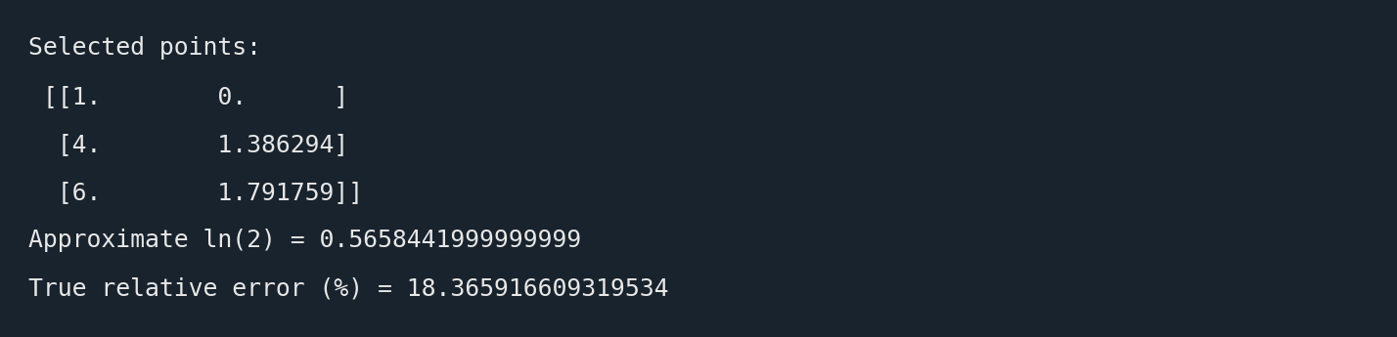
Figure 1: Console snapshot of the Newton interpolation validation.
The approximate value 0.565844 is exactly the value in the lecture and in the textbook [1]. The true relative error against ln(2) = 0.693147 is 18.37 %, which is also the same error reported in the textbook, because a 2nd order polynomial cannot follow the logarithm exactly. This confirms the divided differences and the evaluation are correct.
f.2 Gauss Elimination with Scaled Partial Pivoting Validation
The Gauss function was validated with the lecture example that solves the following system with partial pivoting using the augmented matrix notation:
$$2x_{1} - 6x_{2} - x_{3} = -38$$
$$-3x_{1} - x_{2} + 7x_{3} = -34$$
$$-8x_{1} + x_{2} - 2x_{3} = -26$$
Our function gave:
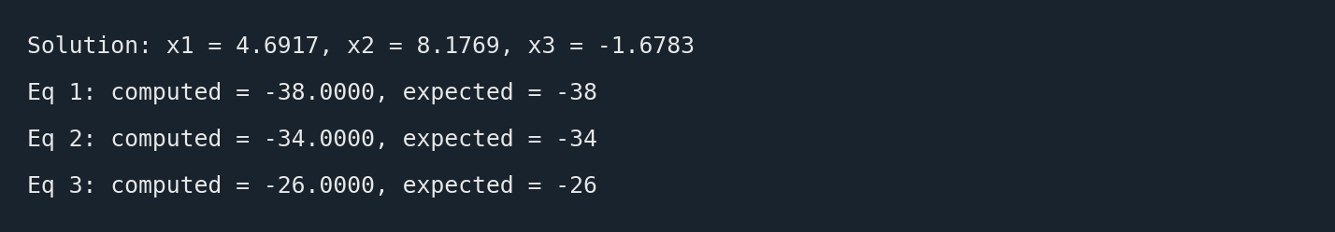
Figure 2: Console snapshot of the Gauss elimination with scaled partial pivoting validation.
As required in the lecture, the solution was checked by back substitution in the original equations. Substituting x1, x2, and x3 back gives exactly −38, −34, and −26, which are the right hand sides of the system. This confirms that the scaling, the row swapping, the forward elimination, and the back substitution are all implemented correctly.
f.3 Thomas Algorithm Validation
The Thomas function was validated with Example 11.1 from chapter 11 of Chapra and Canale [1], which solves the tridiagonal system of the heated rod:
$$f = [2.04, 2.04, 2.04, 2.04] , e = g = [-1, -1, -1] , b = [40.8, 0.8, 0.8, 200.8]$$
Our function gave:
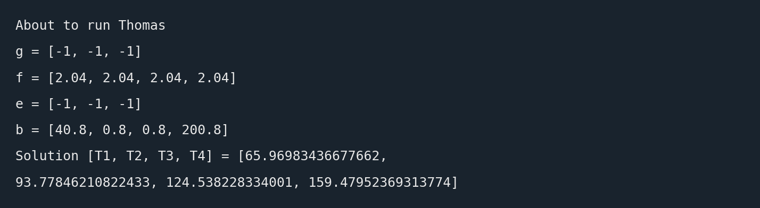
Figure 3: Console snapshot of the Thomas algorithm validation.
The textbook solution is T1 = 65.970, T2 = 93.778, T3 = 124.538, and T4 = 159.480 [1], so our output matches it exactly. This confirms the forward sweep and the back substitution of the Thomas algorithm are correct.
f.4 Euler, Heun, and Midpoint Validation
The ODE solvers were validated with Example 25.5 from the textbook [1], which solves dy/dx = 4e^(0.8x) − 0.5y from x = 0 to x = 4 with a step size of 1 and initial condition y(0) = 2, and tests performing iterations on the corrector equation. Our functions gave the following output:

Figure 4: Console snapshot of the Euler/Heun/Midpoint validation.
x | Heun | Midpoint | Heun (iterated)
0.00 | 2.000000 | 2.000000 | 2.000000
1.00 | 6.701082 | 6.217299 | 6.360949
2.00 | 16.319782 | 14.940739 | 15.302483
3.00 | 37.199249 | 33.941154 | 34.743868
4.00 | 83.337767 | 75.968632 | 77.736445

Table 1: Validation of the ODE solvers against Example 25.5 from Chapra and Canale [1].
The simple Heun values (6.701082, 16.319782, 37.199249, 83.337767) match the textbook values exactly, and the iterated corrector values match the textbook values with a stopping criterion of 0.01 %. The midpoint method values also agree with the textbook. Since the Euler predictor step is inside Heun, this also validates the Euler stepping. This confirms our solvers are correct and can be trusted for the battery problem.

g. Code Flow Chart
Figure 5 shows the flow of the whole program, from reading the data file until the final plots. The code is modular: every numerical method is in its own file and main.py calls them in order.
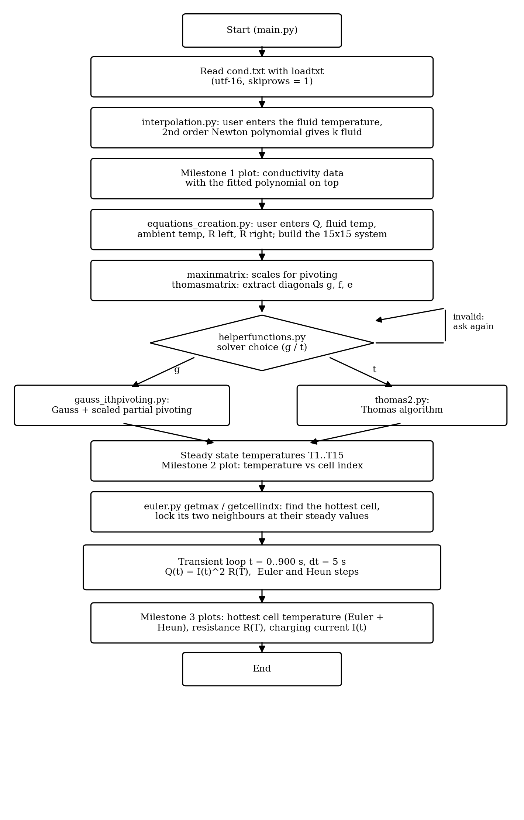
Figure 5: Flow chart of the EV battery thermal simulator.

h. User Manual and Case Study
The code is divided into modules: main.py (the main script that runs everything), interpolation.py (milestone 1), equations_creation.py (builds the resistances, the coefficient matrix, the right hand side, and extracts the three diagonals for Thomas), gauss_ithpivoting.py (Gauss elimination with scaled partial pivoting), thomas2.py (Thomas algorithm), helperfunctions.py (the solver choice and the swap function), and euler.py (the Euler and Heun solvers, R(T), I(t), and the hottest cell functions). To use the code, follow these steps:
Step 1 — Setup. Put all the .py files in one folder, and edit the file_path line in the top of main.py to the path of cond.txt on your computer. The file is read by NumPy loadtxt with encoding utf-16 and skiprows = 1 because it has a header line.
Step 2 — Run main.py and enter the inputs. The program first asks for the fluid temperature for the interpolation, then it asks for the thermal load Q, the fluid temperature, the ambient temperature, and the two boundary resistances. For the test case we enter 25 °C, 5 W, 25 °C, 25 °C, R left = 1 K/W, and R right = 5 K/W. The program directly prints the interpolated conductivity:
Enter fluid temperature: 25
Estimated thermal conductivity at 25.0: 0.40184375
Enter thermal load : 5
Enter fluid temp: 25
Enter ambient temp : 25
Enter R left: 1
Enter R ight: 5
Step 3 — Milestone 1 output. The program plots the conductivity data points (red diamonds) with the fitted 2nd order polynomial evaluated across the temperature range on top of them, and reports the conductivity at the input temperature (0.40184 W/m.K at 25 °C). The polynomial passes through all the data points.
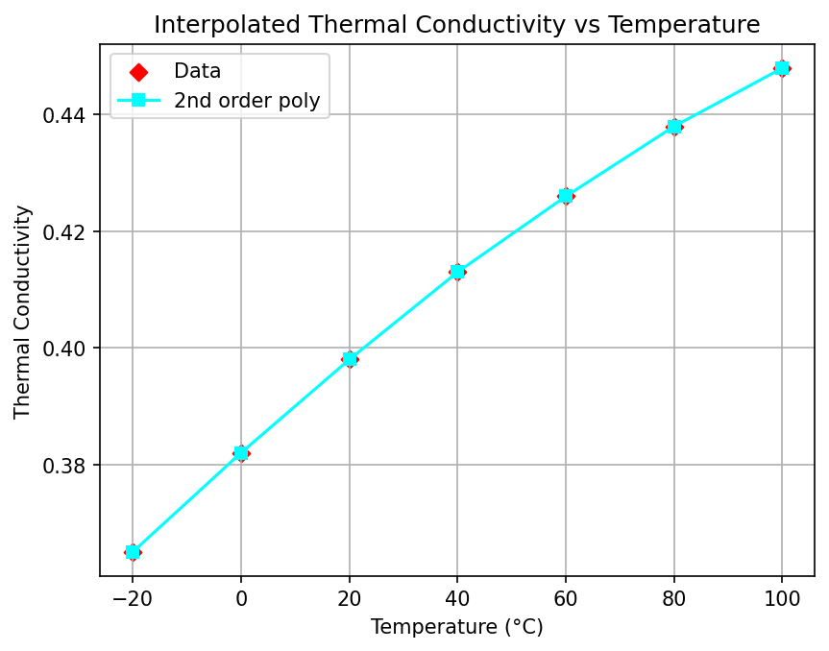
Figure 6: Milestone 1 — coolant thermal conductivity data with the 2nd order Newton polynomial.
Step 4 — Choose the solver. The program asks: What solution method did you choose? (g for gauss/t for thomas). If the user types anything else, the program prints invalid and asks again until a valid choice is entered. Both solvers give the same temperatures because they solve the same system.
Step 5 — Milestone 2 output. The 15 steady state temperatures are printed and plotted against the cell index. The temperatures start at about 44.2 °C at cell 1, reach a maximum of 45.220 °C at cell 6, and then they drop towards cell 15 which loses the most heat through the right boundary. The profile is not symmetric because the two boundary resistances are different. The program then reports the hottest cell:

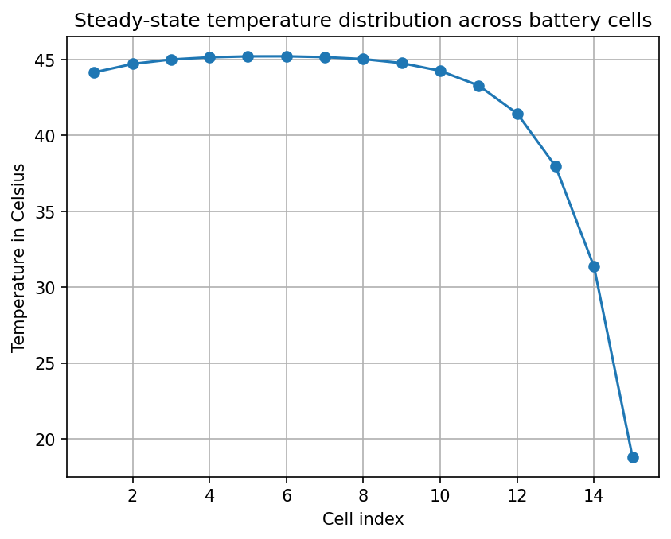
Figure 7: Milestone 2 — steady state temperature of every cell. The hottest cell is cell 6 at 45.220 °C.
Step 6 — Milestone 3 output. The program locks cells 5 and 7 at their steady state temperatures and integrates the hottest cell (cell 6) from t = 0 to 900 s with Δt = 5 s using Euler and Heun. Three plots are produced: the temperature of the hottest cell with both methods, the cell resistance R(T), and the charging current I(t). The temperature rises quickly to about 118.6 °C and stays there while the current is 120 A, then it cools down to about 45.8 °C when the current decays. The Euler and Heun curves are almost on top of each other, so Δt = 5 s is a suitable step. The resistance mirrors the temperature: it drops from 0.011 Ω to about 0.0075 Ω when the cell is hottest, then it recovers. The current is constant at 120 A for 300 s then decays exponentially to about 19.8 A at 900 s.
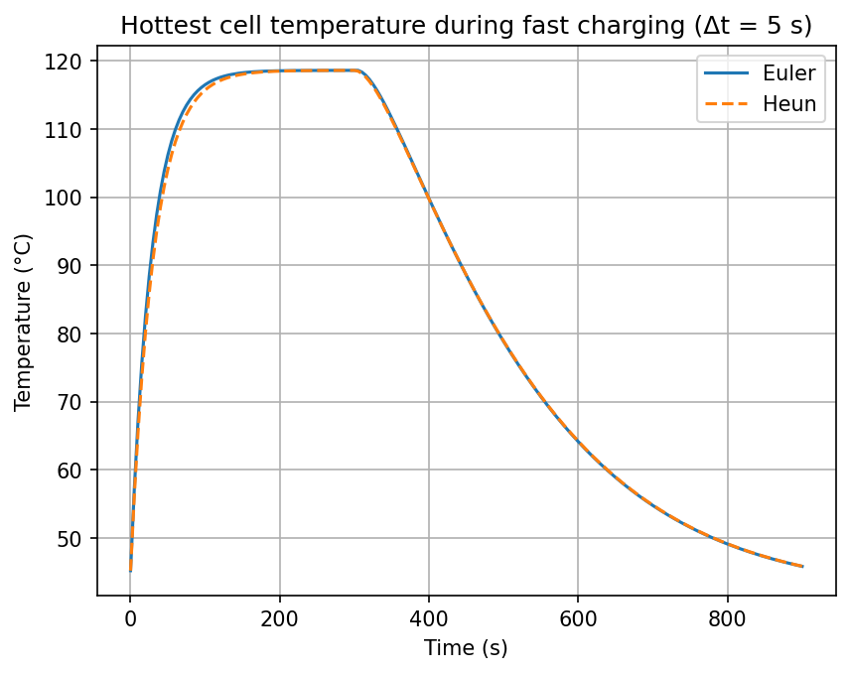
Figure 8: Milestone 3 — hottest cell temperature during fast charging (Δt = 5 s), Euler and Heun.
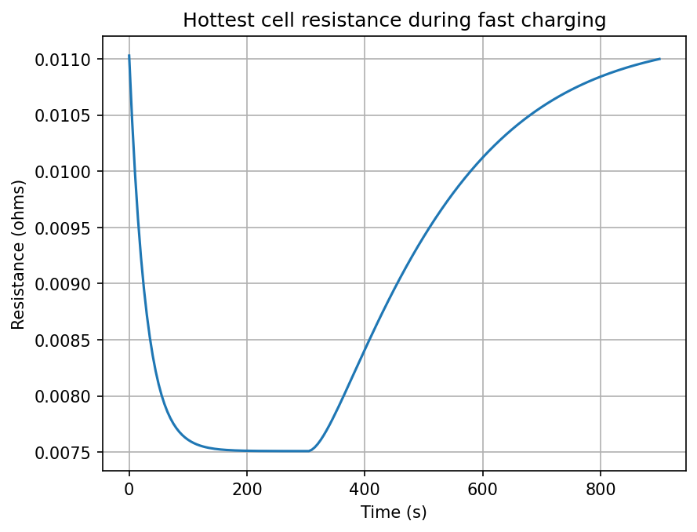
Figure 9: Milestone 3 — cell resistance R(T) during fast charging.
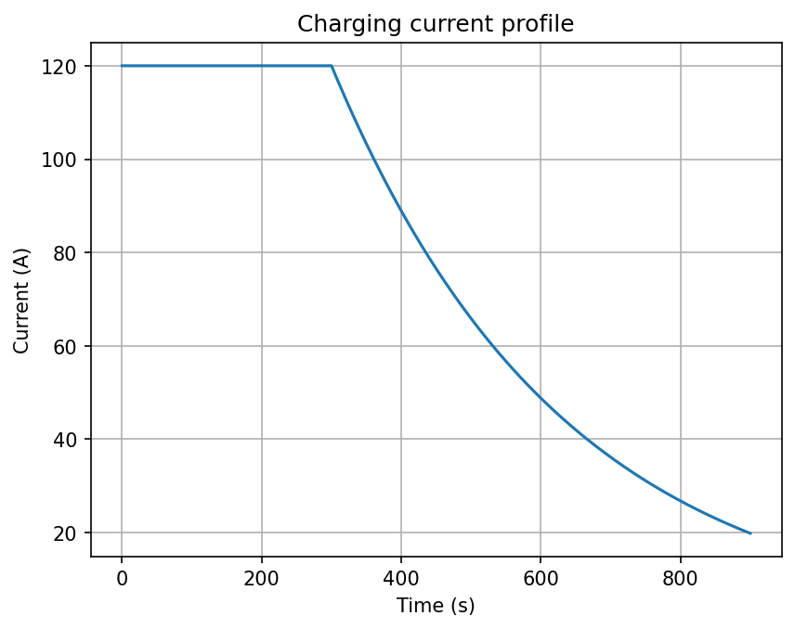
Figure 10: Milestone 3 — charging current profile I(t).
This test case validates the whole code working together: the interpolated conductivity feeds the resistances, the resistances build the system, the solver gives the steady state, and the steady state feeds the transient analysis. Since the peak temperature (about 118.6 °C) is above the 60 °C limit, this charging profile is not safe for this cooling design.
i. Difficulties and Sources of Error
The first difficulty was reading cond.txt. The file is saved in utf-16 with a header line, so loadtxt failed until we added encoding="utf-16" and skiprows=1. The second difficulty was indexing in the interpolation function. At the beginning we looped directly over the list values (for i in barr), so i was a float value and we got the error "list indices must be integers or slices, not float", and also an index out of bounds at barr[i+1]. We fixed it by looping with range(n) so i is always an integer index. Another problem was that Python lists are passed by reference, so the Thomas function was destroying the original arrays; we solved it by taking a .copy() of every array inside the function. Finally, there are small unavoidable numerical errors: the 2nd order interpolation has a truncation error (18.37 % in the ln(2) validation), and Euler is only first order accurate, but with Δt = 5 s the Euler and Heun curves were almost identical, so this error is small.
j. Conclusion
In this project we built a modular Python simulator for the temperature of a row of 15 lithium-ion cells. The simulator combines a 2nd order Newton interpolating polynomial, Gauss elimination with scaled partial pivoting, the Thomas algorithm (bonus), and the Euler and Heun methods (bonus). Every function was validated with a lecture example and gave the correct output, and the full code works together and produces all the required plots. For the test case, the hottest cell is cell 6 at 45.220 °C in steady state, but during fast charging it reaches about 118.6 °C, which exceeds the 60 °C limit. So with this design, the fast charging current should be reduced or the cooling should be improved. For future improvements, we can use a smaller time step or a higher order method like 4th order Runge-Kutta, solve the transient problem for all 15 cells together instead of only the hottest one, and add a simple graphical interface for the inputs.
k.AI prompts
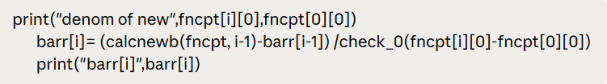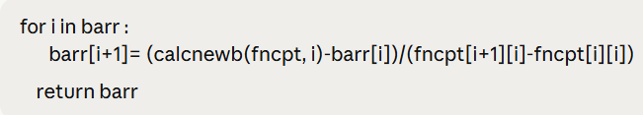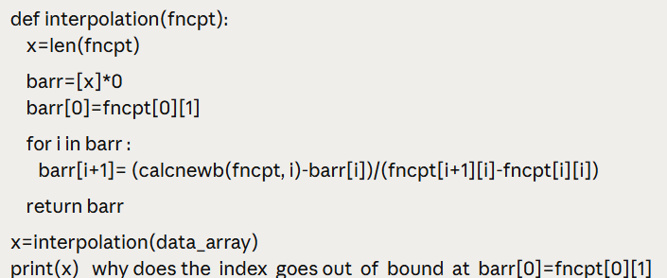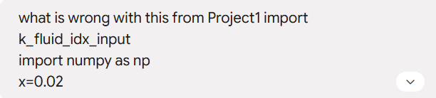


L. References
[1] S. C. Chapra and R. P. Canale, Numerical Methods for Engineers, 6th ed., McGraw-Hill, 2010.
[2] D. Bohne, S. Fischer, and E. Obermeier, “Thermal Conductivity, Density, Viscosity, and Prandtl-Numbers of Ethylene Glycol-Water Mixtures,” Ber. Bunsenges. Phys. Chem., vol. 88, pp. 739–742, 1984.
[3] ENGR 3202 Lecture Notes, The American University in Cairo, Summer 2026.
[4] T. M. Bandhauer, S. Garimella, and T. F. Fuller, “A Critical Review of Thermal Issues in Lithium-Ion Batteries,” Journal of the Electrochemical Society, vol. 158, no. 3, pp. R1–R25, 2011.

